  - The problem at hand is to find the parameters based on the following equality:
$$U3\left(θ,ϕ,λ\right)=\left[\begin{matrix}\cos{\frac{θ}{2}} & -e^{iλ}\sin{\frac{θ}{2}} \\ e^{iϕ}\sin{\frac{θ}{2}} & e^{i(λ+ϕ)}\cos{\frac{θ}{2}}\end{matrix}\right]=\left[\begin{matrix}0 & 1 \\ 1 & 0\end{matrix}\right]=NOT$$
In the following we assume the interval $[0,π]$. Since $\cos{\frac{θ}{2}}=0$, $\frac{θ}{2}$ must equal $\frac{π}{2}$, and thus $θ=π$. Since $\sin{\frac{π}{2}=1}$, $e^{iϕ}=1$ as well, and hence $iϕ=0$ and therefore also $ϕ=0$. Again, since $\sin{\frac{π}{2}=1}$, $-e^{iλ}=1$, and hence by squaring both sides we have $e^{i2λ}=1$ and from this $λ=0$.
  - Along the same lines as in exercise 1.1
$$U3\left(θ,ϕ,λ\right)=\left[\begin{matrix}\cos{\frac{θ}{2}} & -e^{iλ}\sin{\frac{θ}{2}} \\ e^{iϕ}\sin{\frac{θ}{2}} & e^{i(λ+ϕ)}\cos{\frac{θ}{2}}\end{matrix}\right]=\left[\begin{matrix}\frac{1}{\sqrt{2}} & \frac{1}{\sqrt{2}} \\ \frac{1}{\sqrt{2}} & -\frac{1}{\sqrt{2}}\end{matrix}\right]=H$$
In order for $\cos{\frac{θ}{2}=\frac{1}{\sqrt{2}}}$, $\frac{θ}{2}=\frac{π}{4}$ and therefore $θ= \frac{π}{2}$. For this value of $θ$, $\sin{\frac{π}{4}}=\frac{1}{\sqrt{2}}$ as well, and hence $e^{iϕ}=1$. From this it follows that $ϕ=0$. Since $e^{i(λ+ϕ)}=-1$ and given that $ϕ=0$, we have that $e^{iλ}=-1$ and therefore $λ=π$.
  - As in both previous exercises, we set
$$U3\left(θ,ϕ,λ\right)=\left[\begin{matrix}\cos{\frac{θ}{2}} & -e^{iλ}\sin{\frac{θ}{2}} \\ e^{iϕ}\sin{\frac{θ}{2}} & e^{i(λ+ϕ)}\cos{\frac{θ}{2}}\end{matrix}\right]=\left[\begin{matrix}1 & 0 \\ 0 & -1\end{matrix}\right]=Z$$
With $\cos{\frac{θ}{2}}=1$ it follows that $θ=0$. Since $\cos{\frac{π}{2}}=0$, it must be the case that $e^{i(λ+ϕ)}=-1$. It must therefore be the case that $λ+ϕ=π$. With $\sin{\frac{π}{2}}=0$ the values of $λ$ and $ϕ$ cannot be established from the off-diagonal formulas. For that reason, the gate Z can have many parametrizations, including when $ϕ=λ=\frac{π}{2}$.
  - Again, as above
$$U3\left(θ,ϕ,λ\right)=\left[\begin{matrix}\cos{\frac{θ}{2}} & -e^{iλ}\sin{\frac{θ}{2}} \\ e^{iϕ}\sin{\frac{θ}{2}} & e^{i(λ+ϕ)}\cos{\frac{θ}{2}}\end{matrix}\right]=\left[\begin{matrix}0 & -i \\ i & 0\end{matrix}\right]=Y$$
With $\cos{\frac{θ}{2}}=0$, $θ=π$. $\sin{\frac{π}{2}}=1$. Hence, $e^{iϕ}=i$ and $-e^{iλ}=-i$. From these equations we obtain the values $ϕ=\frac{π}{2}$ and $λ=\frac{π}{2}$.
  - As above,
$$U3\left(θ,ϕ,λ\right)=\left[\begin{matrix}\cos{\frac{θ}{2}} & -e^{iλ}\sin{\frac{θ}{2}} \\ e^{iϕ}\sin{\frac{θ}{2}} & e^{i(λ+ϕ)}\cos{\frac{θ}{2}}\end{matrix}\right]=\left[\begin{matrix}1 & 0 \\ 0 & i\end{matrix}\right]=S$$
With $\cos{\frac{θ}{2}}=1$, $θ=0$. Then $e^{i(λ+ϕ)}=i$. This means that $λ+ϕ=\frac{π}{2}$. Again, there are multiple parametrizations that achieve this, e.g., $λ=ϕ=\frac{π}{4}$.
  - The $S^{+}$ gate differs from the S gate in the sign of the complex number i only. Therefore, the parameters are as follows: $θ=0$ and $λ+ϕ=\frac{3π}{2}$.
  - The gate T differs from the S only by having the value $\frac{1+i}{\sqrt{2}}$ instead of i. Therefore, the parameter $θ=0$, while for the remaining two parameters there are multiple values for which holds that $e^{i(λ+ϕ)}=\frac{1+i}{\sqrt{2}}$. To obtain the parameters we use trigonometric identities
$$e^{i\left(λ+ϕ\right)}=e^{iλ}e^{iϕ}=(\cos{λ+i\sin{λ)(\cos{ϕ+i\sin{ϕ)}}}}$$
This corresponds to
$$\cos{λ\cos{ϕ+i\sin{ϕ\cos{λ+i\sin{λ\cos{ϕ-\sin{ϕ\sin{λ }}}}}}}}=(\cos{λ\cos{ϕ-\sin{λ\sin{ϕ}})+i(\sin{ϕ\cos{λ+\sin{λ\cos{ϕ}}}})=cos⁡(λ+ϕ)+i sin⁡(λ+ϕ)=\frac{1}{\sqrt{2}}}}+\frac{i}{\sqrt{2}}$$
Thus we have $λ+ϕ=\frac{π}{4}$.
  - The reasoning regarding the $T^{+}$ gate is similar to that for the T gate. Instead of $\frac{1+i}{\sqrt{2}}$, the $T^{+}$has its conjugate $\frac{1-i}{\sqrt{2}}$. The parameter $θ=0$. Using trigonometric identities
$$\cos\left(λ+ϕ\right)+i\sin\left(λ+ϕ\right)=\frac{1}{\sqrt{2}}-\frac{i}{\sqrt{2}}$$
From $\cos\left(λ+ϕ\right)=\frac{1}{\sqrt{2}}$ and $\sin\left(λ+ϕ\right)=-\frac{1}{\sqrt{2}}$ we have that $λ+ϕ={315}^{∘}=\frac{7π}{4}$. Therefore, any combination of values for $λ$ and $ϕ$ that conforms to the condition $λ+ϕ=\frac{7π}{4}$ is a valid parametrization.
  - Finding the parameters for the identity gate is straightforward. From $\cos{\frac{θ}{2}}=1$ it follows that $θ=0$. Then, from $e^{i(λ+ϕ)}=1$ it follows that $λ+ϕ=0$ and therefore $λ=ϕ=0$.
  - For the gate
$$U1\left(λ\right)=\left[\begin{matrix}1 & 0 \\ 0 & e^{iλ}\end{matrix}\right]$$
$θ=0$, as above. Then, from $e^{i(λ+ϕ)}=e^{iλ}$ it follows that $ϕ=0$.
  - For the gate $U2\left(ϕ,λ\right)$ we have
$$U3\left(θ,ϕ,λ\right)=\left[\begin{matrix}\cos{\frac{θ}{2}} & -e^{iλ}\sin{\frac{θ}{2}} \\ e^{iϕ}\sin{\frac{θ}{2}} & e^{i(λ+ϕ)}\cos{\frac{θ}{2}}\end{matrix}\right]=\left[\begin{matrix}\frac{1}{\sqrt{2}} & -\frac{e^{iλ}}{\sqrt{2}} \\ \frac{e^{iϕ}}{\sqrt{2}} & \frac{e^{i(λ+ϕ)}}{\sqrt{2}}\end{matrix}\right]=U2(ϕ,λ)$$
we have that $\cos{\frac{θ}{2}}=\frac{1}{\sqrt{2}}$, and therefore $θ=\frac{π}{2}$.

Solutions to chapter 2

2.1 To obtain the required operation, 3 quantum bits and 3 classical bits are needed. In the following circuit, q[0] represents the x operand, q[1] represents the y operand, while q[2] is the additional bit in the OR gate introduced in the material of this chapter. First, set the two operands into a superposition by applying to each a Hadamard gate H. As the OR gate requires that the auxialiary quantum bit be equal 1, apply the NOT gate to it. The OR gate would require a total of 4 NOT gates. It can however be simplified due to the fact that one of the operands, namely x, is negated. The equivalence of the two subcircuits can be easily checked by writing down truth tables for each of them. Note that the output is presented in the order c[2], c[1], c[0].
The circuit:
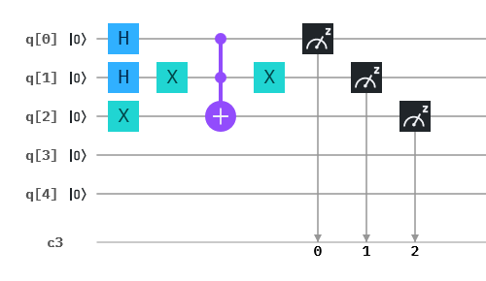
The code:
- OPENQASM 2.0;
- include "qelib1.inc";
- qreg q[5];
- creg c[3];
- h q[0];
- h q[1];
- x q[1];
- x q[2];
- ccx q[0],q[1],q[2];
- x q[1];
- measure q[0] -> c[0];
- measure q[1] -> c[1];
- measure q[2] -> c[2];

The output:
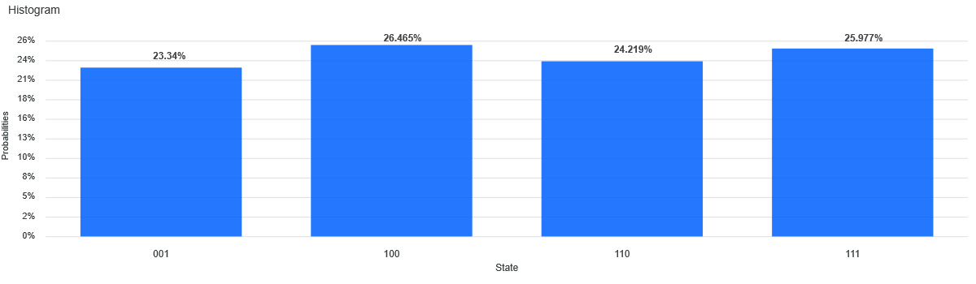
2.2 To obtain the required operation, 3 quantum bits and 3 classical bits are needed. q[0] represents the x operand, q[1] represents y, while q[2] is the additional bit in the OR gate introduced in the material of this chapter. First, set the two operands into a superposition by applying to each a Hadamard gate H. As the OR gate requires that the auxialiary quantum bit be equal 1, apply the Pauli X gate to it. The OR gate would require a total of 4 X gates. It can however be simplified due to the fact that one of the operands, namely y, is negated. Note that the output is presented in the order c[2], c[1], c[0].
The circuit:
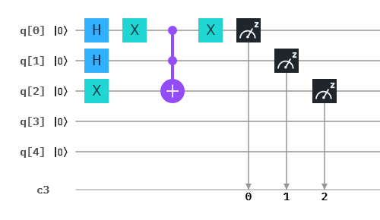
The code:
- OPENQASM 2.0;
- include "qelib1.inc";
- qreg q[5];
- creg c[3];
- h q[0];
- h q[1];
- x q[2];
- x q[0];
- ccx q[0],q[1],q[2];
- x q[0];
- measure q[0] -> c[0];
- measure q[1] -> c[1];
- measure q[2] -> c[2];];
- measure q[0] -> c[0];
- measure q[1] -> c[1];
- measure q[2] -> c[2];

The output:
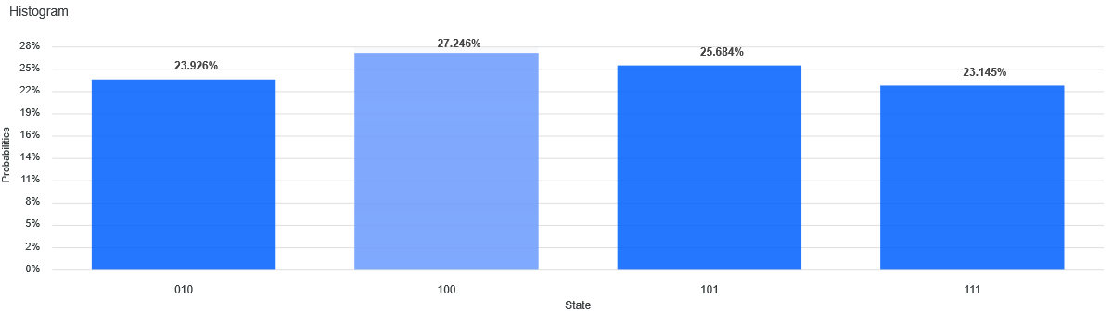
2.3 A possible implementation of this operation could be as below. To this end, 5 quantum bits and 3 classical bits are required. Observe that $\overline{y}∧\left(x∨\overline{x}\right)=(\overline{y}∧x)∨(\overline{y}∧\overline{x})$. Therefore, in the following, we separate the operations into three parts: $(\overline{y}∧x)$, $(\overline{y}∧\overline{x})$, and the OR operation on the two. The three operations are separated by barriers (barriers are only used for convenience and they do not contribute to the meaning of the circuit). Everything up to the first barrier, except the two Hadamard gates, encodes the clause $(\overline{y}∧x)$. Clause $(\overline{y}∧\overline{x})$ is encoded between the first and the second barrier. The OR operation on the two clauses is encoded between the second and the third barrier. In the following circuit, q[0] represents x, q[1] represents y, q[2] is the auxialiary quantum bit for the AND operation in the term $(\overline{y}∧x)$, q[3] is the auxiliary bit for the AND operation in the term $(\overline{y}∧\overline{x})$, while q[4] is the auxiliary bit for the OR operation mentioned above. Note that the output is presented in the order c[2], c[1], c[0].
The circuit:
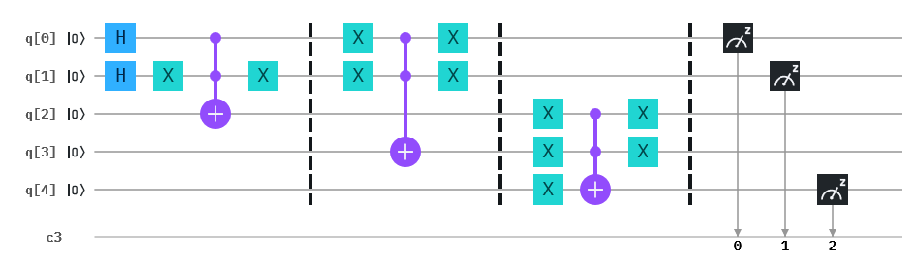
The code:
- OPENQASM 2.0;
- include "qelib1.inc";
- qreg q[5];
- creg c[3];
- h q[0];
- h q[1];
- x q[1];
- ccx q[0],q[1],q[2];
- x q[1];
- barrier q[0],q[1],q[2],q[3],q[4];
- x q[0];
- x q[1];
- ccx q[0],q[1],q[3];
- x q[0];
- x q[1];
- barrier q[0],q[1],q[2],q[3],q[4];
- x q[2];
- x q[3];
- x q[4];
- ccx q[2],q[3],q[4];
- x q[2];
- x q[3];
- barrier q[0],q[1],q[2],q[3],q[4];
- measure q[0] -> c[0];
- measure q[1] -> c[1];
- measure q[4] -> c[2];

The output:
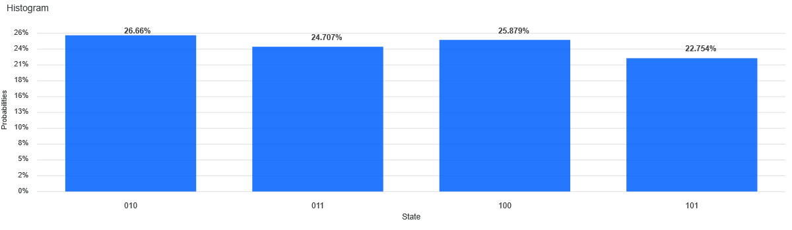
2.4 A possible implementation of this operation could be as below. To this end, 5 quantum bits and 3 classical bits are required. The separation of operations is along the same lines as in the previous exercise. Observe that $\overline{x}∧\left(y∨\overline{y}\right)=(\overline{x}∧y)∨(\overline{x}∧\overline{y})$. Therefore, in the following, we separate the operations into three parts: $(\overline{x}∧y)$, $(\overline{x}∧\overline{y})$, and the OR operation on the two. The three operations are separated by barriers (barriers are only used for convenience and they do not contribute to the meaning of the circuit). Everything up to the first barrier, except the two Hadamard gates, encodes the clause $(\overline{x}∧y)$. Clause $(\overline{x}∧\overline{y})$ is encoded between the first and the second barrier. The OR operation on the two clauses is encoded between the second and the third barrier. q[0] represents x, q[1] represents y, q[2] is the auxialiary quantum bit for the AND operation in the term $(\overline{x}∧y)$, q[3] is the auxiliary bit for the AND operation in the term $(\overline{x}∧\overline{y})$, while q[4] is the auxiliary bit for the OR operation mentioned above. Note that the output is presented in the order c[2], c[1], c[0].
The circuit:
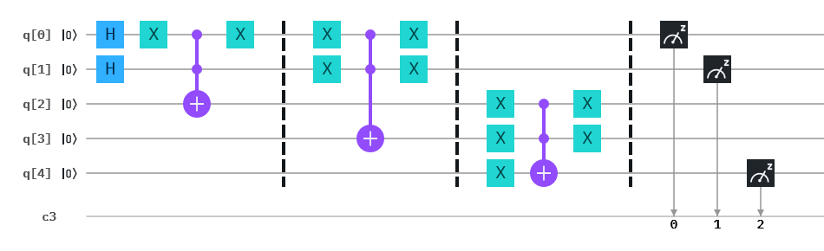
The code:
- OPENQASM 2.0;
- include "qelib1.inc";
- qreg q[5];
- creg c[3];
- h q[0];
- h q[1];
- x q[0];
- ccx q[0],q[1],q[2];
- x q[0];
- barrier q[0],q[1],q[2],q[3],q[4];
- x q[0];
- x q[1];
- ccx q[0],q[1],q[3];
- x q[0];
- x q[1];
- barrier q[0],q[1],q[2],q[3],q[4];
- x q[2];
- x q[3];
- x q[4];
- ccx q[2],q[3],q[4];
- x q[2];
- x q[3];
- barrier q[0],q[1],q[2],q[3],q[4];
- measure q[0] -> c[0];
- measure q[1] -> c[1];
- measure q[4] -> c[2];

The output:
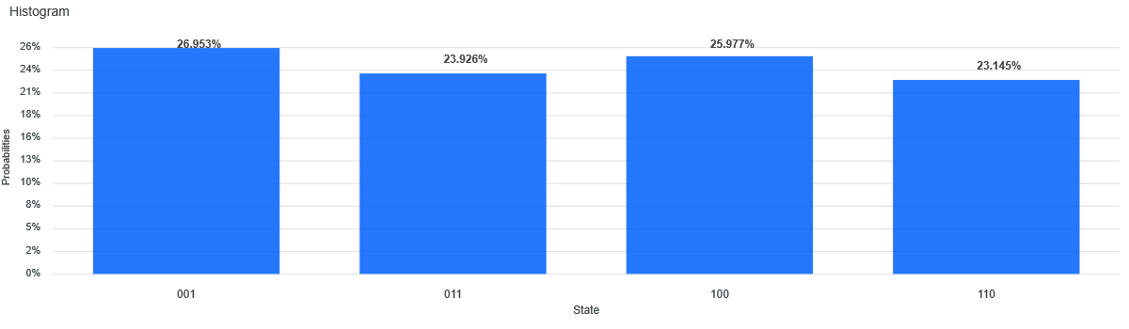
2.5 To obtain the required operation, 3 quantum bits and 3 classical bits are needed. q[0] represents the x operand, q[1] represents y, while q[2] is the additional bit in the AND gate introduced in the material of this chapter. First, set the two operands into a superposition by applying to each a Hadamard gate H. The two X gates are to account for the fact that operand x is negated. Note that the output is presented in the order c[2], c[1], c[0].
The circuit:
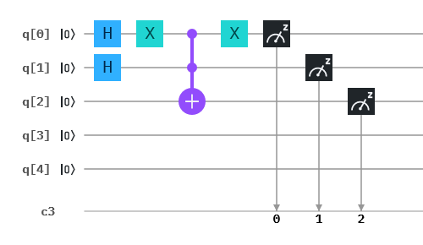
The code:
- OPENQASM 2.0;
- include "qelib1.inc";
- qreg q[5];
- creg c[3];
- h q[0];
- h q[1];
- x q[0];
- ccx q[0],q[1],q[2];
- x q[0];
- measure q[0] -> c[0];
- measure q[1] -> c[1];
- measure q[2] -> c[2];

The output:
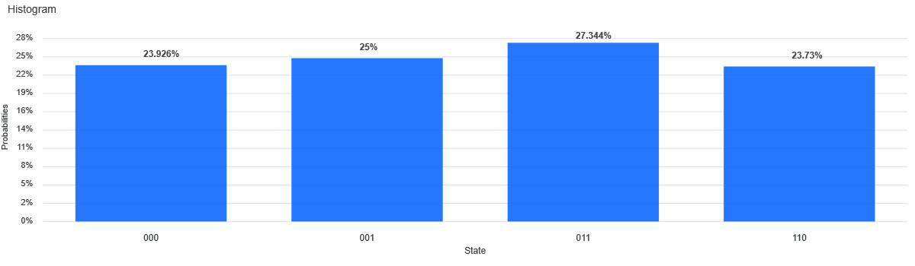
2.6 To obtain the required operation, 3 quantum bits and 3 classical bits are needed. q[0] represents the x operand, q[1] represents y, while q[2] is the additional bit in the AND gate introduced in the material of this chapter. First, set the two operands into a superposition by applying to each a Hadamard gate H. The two X gates are to account for the fact that operand y is negated. Note that the output is presented in the order c[2], c[1], c[0].
The circuit:
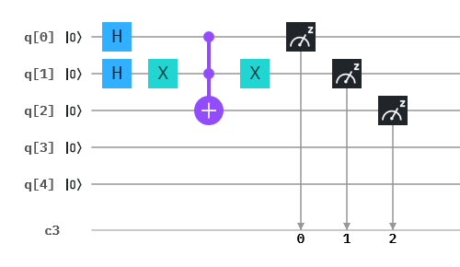
The code:
- OPENQASM 2.0;
- include "qelib1.inc";
- qreg q[5];
- creg c[3];
- h q[0];
- h q[1];
- x q[1];
- ccx q[0],q[1],q[2];
- x q[1];
- measure q[0] -> c[0];
- measure q[1] -> c[1];
- measure q[2] -> c[2];

The output:
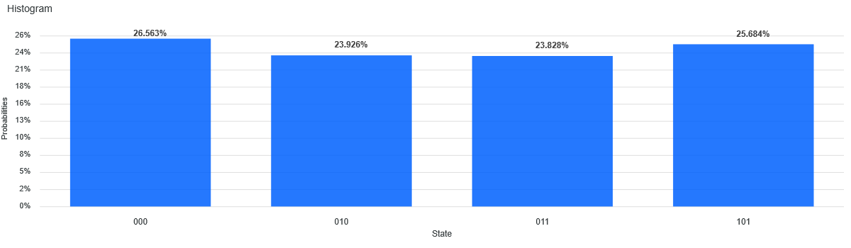

Solutions to chapter 3

3.1 The circuit for the satisfiability problem specified by the oracle $F\left(x_{1},x_{2}\right)=\overline{x_{1}}∧x_{2}$ is very similar to the one given for $F\left(x_{1},x_{2}\right)=x_{1}∧x_{2}$ in this chapter (see also the answer to exercise 3.4). The difference is that the input $x_{1}$ is negated (that is q[3]). q[0] is a workspace qubit, q[1] is not used, q[2] represents $s_{2}$, q[3] is for $x_{1}$, while q[4] is for $x_{2}$. We introduce barriers to separate different parts of the code. Everything up to the first barrier represents the initial encoding. q[0] represents the state $\left|-\right\rangle =\frac{1}{\sqrt{2}}(|0⟩-|1⟩)$, as in the material, while q[3] and q[4] are set into a uniform superposition. The oracle that negates the amplitude of the qubit for which the condition $\overline{x_{1}}∧x_{2}=1$ is fulfilled is located between the first and the second barrier. To represent the fact that the value of $x_{1}$ is negated, the NOT gate is used on the qubit representing $x_{1}$. After the oracle has completed its task, another NOT gate is applied to $x_{1}$ to uncompute. The circuit part between the second and the third barriers has been introduced in the material of this chapter and encodes the Grover diffusion operator.
The circuit:
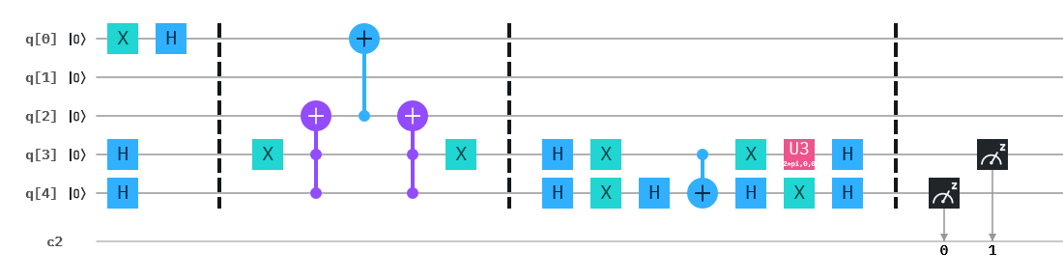
The code:
- OPENQASM 2.0;
- include "qelib1.inc";
- qreg q[5];
- creg c[2];
- x q[0];
- h q[3];
- h q[4];
- h q[0];
- barrier q[0],q[1],q[2],q[3],q[4];
- x q[3];
- ccx q[4],q[3],q[2];
- cx q[2],q[0];
- ccx q[4],q[3],q[2];
- x q[3];
- barrier q[0],q[1],q[2],q[3],q[4];
- h q[3];
- h q[4];
- x q[3];
- x q[4];
- h q[4];
- cx q[3],q[4];
- x q[3];
- h q[4];
- u3(2*pi,0,0) q[3];
- x q[4];
- h q[3];
- h q[4];
- barrier q[0],q[1],q[2],q[3],q[4];
- measure q[4] -> c[0];
- measure q[3] -> c[1];

The output:
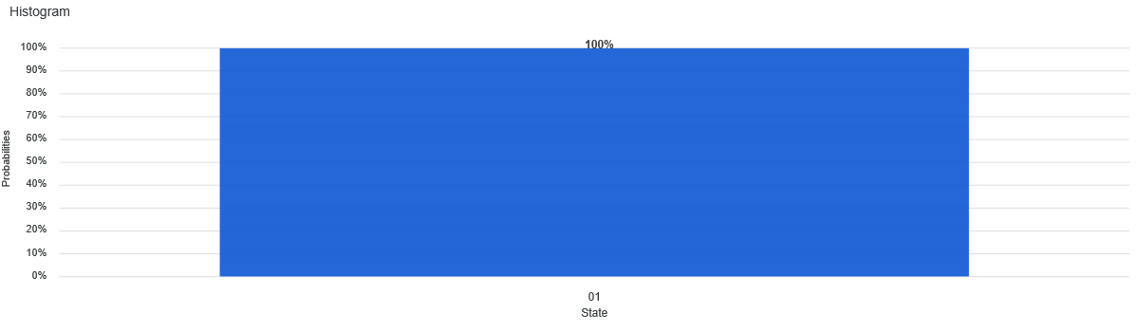
3.2 The circuit for the satisfiability problem specified by the oracle $F\left(x_{1},x_{2}\right)=x_{1}∧\overline{x_{2}}$ is very similar to the one given for $F\left(x_{1},x_{2}\right)=\overline{x_{1}}∧x_{2}$ in exercise 3.1. The difference is that the input $x_{2}$ is negated (that is q[2]) instead of $x_{1}$. q[0] is a workspace qubit, q[1] is not used, q[2] represents $s_{2}$, q[3] is for $x_{1}$, while q[4] is for $x_{2}$. We introduce barriers to separate different parts of the code. Everything up to the first barrier represents the initial encoding. q[0] represents the state $\left|-\right\rangle =\frac{1}{\sqrt{2}}(|0⟩-|1⟩)$, as in the material, while q[3] and q[4] are set into a uniform superposition. The oracle that negates the amplitude of the qubit for which the condition $x_{1}∧\overline{x_{2}}=1$ is fulfilled is located between the first and the second barrier. To represent the fact that the value of $x_{2}$ is negated, the NOT gate is used on the qubit representing $x_{2}$. After the oracle has completed its task, another NOT gate is applied to $x_{2}$ to uncompute. The circuit part between the second and the third barriers has been introduced in the material of this chapter and encodes the Grover diffusion operator.
The circuit:
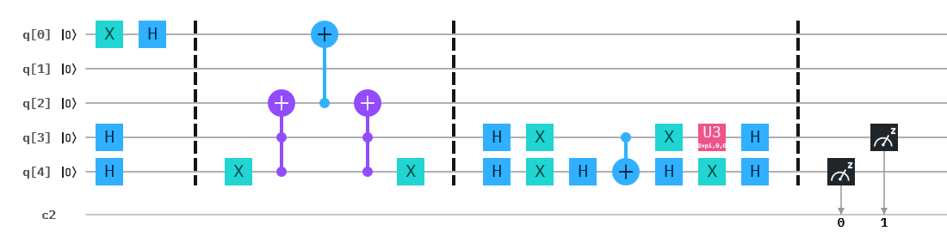
The code:
- OPENQASM 2.0;
- include "qelib1.inc";
- qreg q[5];
- creg c[2];
- x q[0];
- h q[3];
- h q[4];
- h q[0];
- barrier q[0],q[1],q[2],q[3],q[4];
- x q[4];
- ccx q[4],q[3],q[2];
- cx q[2],q[0];
- ccx q[4],q[3],q[2];
- x q[4];
- barrier q[0],q[1],q[2],q[3],q[4];
- h q[3];
- h q[4];
- x q[3];
- x q[4];
- h q[4];
- cx q[3],q[4];
- x q[3];
- h q[4];
- u3(2*pi,0,0) q[3];
- x q[4];
- h q[3];
- h q[4];
- barrier q[0],q[1],q[2],q[3],q[4];
- measure q[4] -> c[0];
- measure q[3] -> c[1];

The output:
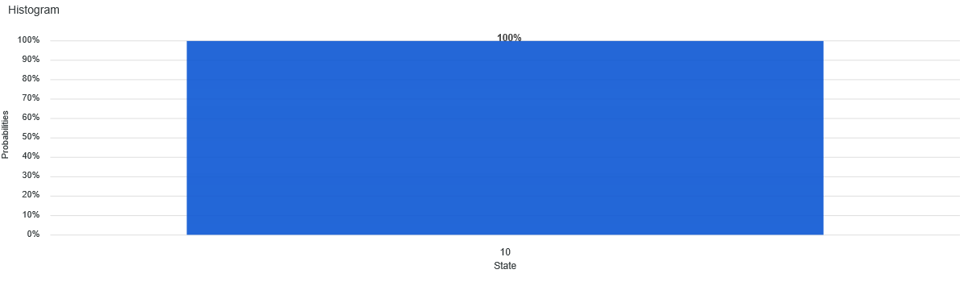
3.3 In theory, the circuit for the satisfiability problem specified by the oracle $F\left(x_{1},x_{2}\right)=\overline{x_{1}∧x_{2}}$ should be very similar to the one given for $F\left(x_{1},x_{2}\right)=x_{1}∧x_{2}$ in this chapter (see also the answer to exercise 3.4). The difference would be that the quantum bit q[2] is negated in order to represent the NAND gate. q[0] is a workspace qubit, q[1] is not used, q[2] represents $s_{2}$, q[3] is for $x_{1}$, while q[4] is for $x_{2}$. We introduce barriers to separate different parts of the code. Everything up to the first barrier represents the initial encoding. q[0] represents the state $\left|-\right\rangle =\frac{1}{\sqrt{2}}(|0⟩-|1⟩)$, as in the material, while q[3] and q[4] are set into a uniform superposition. The oracle that negates the amplitude of the qubit for which the condition $\overline{x_{1}∧x_{2}} =1$ is fulfilled is located between the first and the second barrier. As mentioned above, the NOT gate is used on the qubit representing $s_{2}$. After the oracle has completed its task, another NOT gate is applied to $s_{2}$ to uncompute. The circuit part between the second and the third barriers has been introduced in the material of this chapter and encodes the Grover diffusion operator. After executing the code we notice that the obtained output is incorrect. In fact it shows the state $|11⟩$ with probability 1. The correct answer should have included equal probabilities for three states: $|00⟩$, $|01⟩$, and $|10⟩$. These three states are the correct outcomes for the NAND gate. The reason we obtained the wrong answer is that Grover’s algorithm imposes a limitation on the ratio between the number of answers (A) and the number of all opossible outcomes (O). This limitation is $\frac{A}{O}<\frac{1}{2}$. In this exercise, this ratio is $\frac{3}{4}>\frac{1}{2}$ however.
The circuit:
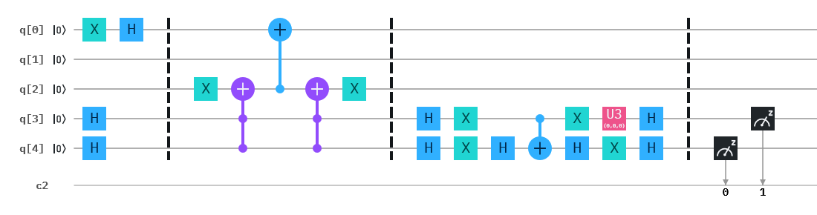
The code:
- OPENQASM 2.0;
- include "qelib1.inc";
- qreg q[5];
- creg c[2];
- x q[0];
- h q[3];
- h q[4];
- h q[0];
- barrier q[0],q[1],q[2],q[3],q[4];
- x q[2];
- ccx q[4],q[3],q[2];
- cx q[2],q[0];
- ccx q[4],q[3],q[2];
- x q[2];
- barrier q[0],q[1],q[2],q[3],q[4];
- h q[3];
- h q[4];
- x q[3];
- x q[4];
- h q[4];
- cx q[3],q[4];
- x q[3];
- h q[4];
- u3(0,0,0) q[3];
- x q[4];
- h q[3];
- h q[4];
- barrier q[0],q[1],q[2],q[3],q[4];
- measure q[4] -> c[0];
- measure q[3] -> c[1];

The output:
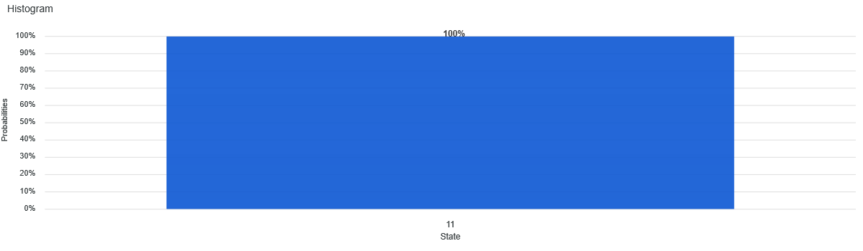

3.4 The circuit for the satisfiability problem specified by the oracle $F\left(x_{1},x_{2}\right)=x_{1}∧x_{2}$ which was given in the material of this chapter, can be simplified by replacing the twelve gates used to represent the CCNOT operation with the CCNOT gate itself (in code: ccx). As the procedure of deriving the circuit has been described in detail in the material, here we only present the corresponding circuit, the code and its output. As before, q[0] is a workspace qubit, q[1] is not used, q[2] represents $s_{2}$, q[3] is for $x_{1}$, while q[4] is for $x_{2}$. We introduce barriers to separate different parts of the code. Everything up to the first barrier represents the initial encoding. q[0] represents the state $\left|-\right\rangle =\frac{1}{\sqrt{2}}(|0⟩-|1⟩)$, as in the material, while q[3] and q[4] are set into a uniform superposition. The oracle that negates the amplitude of the qubit for which the condition $x_{1}∧x_{2}=1$ is fulfilled is located between the first and the second barrier. The circuit part between the second and the third barriers has been introduced in the material of this chapter and encodes the Grover diffusion operator.
The circuit:
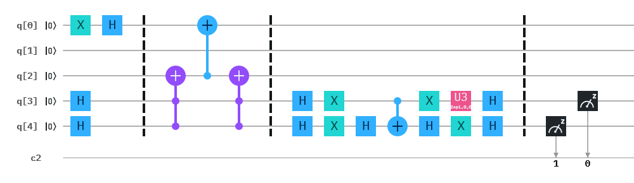
The code:
- OPENQASM 2.0;
- include "qelib1.inc";
- qreg q[5];
- creg c[2];
- x q[0];
- h q[3];
- h q[4];
- h q[0];
- barrier q[0],q[1],q[2],q[3],q[4];
- ccx q[4],q[3],q[2];
- cx q[2],q[0];
- ccx q[4],q[3],q[2];
- barrier q[0],q[1],q[2],q[3],q[4];
- h q[3];
- h q[4];
- x q[3];
- x q[4];
- h q[4];
- cx q[3],q[4];
- x q[3];
- h q[4];
- u3(2*pi,0,0) q[3];
- x q[4];
- h q[3];
- h q[4];
- barrier q[0],q[1],q[2],q[3],q[4];
- measure q[4] -> c[1];
- measure q[3] -> c[0];

The output:
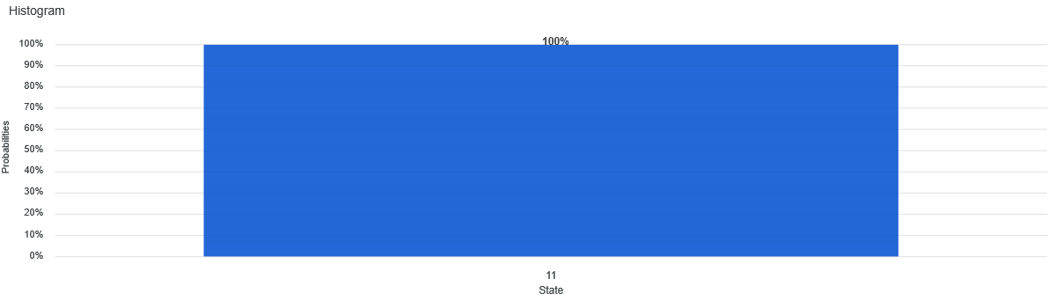

Solutions to chapter 4

4.1 The mapping this oracle performs is $a_{1}a_{2}a_{3}a_{4}→\frac{1}{4}e^{2πi×0.a_{2}a_{3}a_{4}}=\frac{1}{4}e^{2πi\left(\frac{a_{2}}{2}+\frac{a_{3}}{4}+\frac{a_{4}}{8}\right)}$. The following table shows the particular results. Input 0/1 indicates that the respective value is either 0 or 1.
$$a_{1}$$ | $$a_{2}$$ | $$a_{3}$$ | $$a_{4}$$ | $$\frac{1}{4}e^{2πi\left(\frac{a_{2}}{2}+\frac{a_{3}}{4}+\frac{a_{4}}{8}\right)}$$
0/1 | 0 | 0 | 0 | $$1/4$$
0/1 | 0 | 0 | 1 | $${\sqrt{2}}/8+{i\sqrt{2}}/8$$
0/1 | 0 | 1 | 0 | $$i/4$$
0/1 | 0 | 1 | 1 | $$-{\sqrt{2}}/8+{i\sqrt{2}}/8$$
0/1 | 1 | 0 | 0 | $$-1/4$$
0/1 | 1 | 0 | 1 | $$-{\sqrt{2}}/8-{i\sqrt{2}}/8$$
0/1 | 1 | 1 | 0 | $$-i/4$$
0/1 | 1 | 1 | 1 | $${\sqrt{2}}/8-{i\sqrt{2}}/8$$
This corresponds to the sequence of rotations $0°, 45°, 90°, 125°, 180°, 225°, 270°, 315°$. As these values (see the table above) appear twice, the expected frequency $f$ is 2. With this the period is $r=8$.
The solution follows closely that already introduced in the material of this chapter. Quantum bits q[0], q[1], q[2], and q[3] correspond to $a_{1}, a_{2}, a_{3}, a_{4}$, respectively. The first column indicates that all 4 quantum bits are set into a uniform superposition by applying to them the Hadamard gate. In the next column, the respective rotations are encoded. In accordance with the mapping formula, quantum bit q[1] is rotated by $180°$, q[2] by $90°$, and q[3] by $45°$. These operations are delineated by the barrier. After the barrier, the inverse quantum Fourier transform is applied. This transformation is the same (starting in row 13 of the code) as introduced in the chapter material. What changes is the application of the U1 gates to the qubits q[1], q[2], q[3] corresponding to $a_{2}, a_{3}, a_{4}$, respectively.
The circuit:
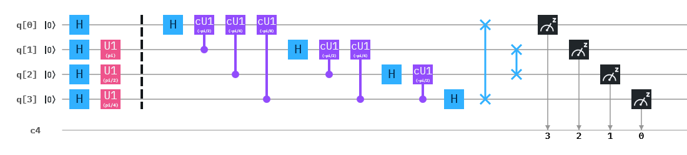
The code:
- OPENQASM 2.0;
- include "qelib1.inc";
- qreg q[4];
- creg c[4];
- h q[0];
- h q[1];
- h q[2];
- h q[3];
- u1(pi) q[1];
- u1(pi/2) q[2];
- u1(pi/4) q[3];
- barrier q[0],q[1],q[2],q[3];
- h q[0];
- cu1(-pi/2) q[1],q[0];
- cu1(-pi/4) q[2],q[0];
- cu1(-pi/8) q[3],q[0];
- h q[1];
- cu1(-pi/2) q[2],q[1];
- cu1(-pi/4) q[3],q[1];
- h q[2];
- cu1(-pi/2) q[3],q[2];
- h q[3];
- swap q[0],q[3];
- swap q[1],q[2];
- measure q[0] -> c[3];
- measure q[1] -> c[2];
- measure q[2] -> c[1];
- measure q[3] -> c[0];

The output:
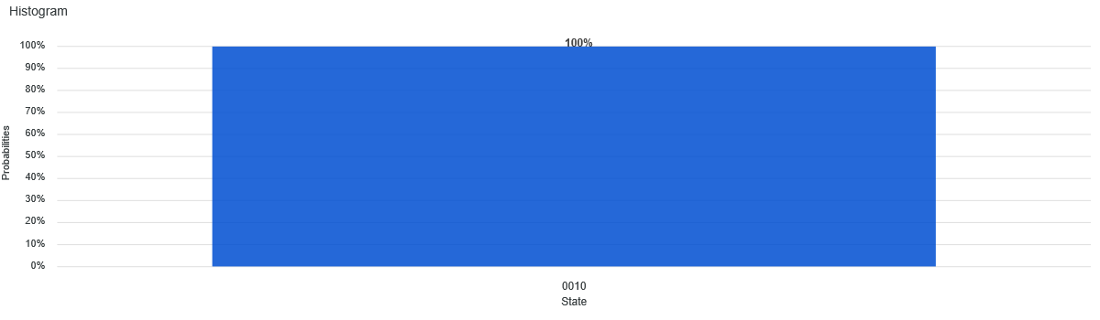
4.2 The mapping this oracle performs is $a_{1}a_{2}a_{3}→\frac{1}{2\sqrt{2}}e^{2πi×0.a_{3}}=\frac{1}{2\sqrt{2}}e^{2πi\left(\frac{a_{3}}{2}\right)}=\frac{1}{2\sqrt{2}}e^{iπa_{3}}$. The following table shows the particular results. Input 0/1 indicates that the respective value is either 0 or 1.
$$a_{1}a_{2}$$ | $$a_{3}$$ | $$\frac{1}{2\sqrt{2}}e^{iπa_{3}}$$
00/01/10/11 | 0 | $$1/{2\sqrt{2}}$$
00/01/10/11 | 1 | $${-1}/{2\sqrt{2}}$$

The oracle oscillates between two values corresponding to rotations by$180°$. The frequency is 4, whereby the period equals 8/4=2. Our solution follows closely that already introduced in the material of this chapter. Quantum bits q[0], q[1], and q[2] correspond to $a_{1}, a_{2}, a_{3}$, respectively. 3 classical registers are needed to encode the output. The first column indicates that all 3 quantum bits are set into a uniform superposition by applying to them the Hadamard gate. In the next column, the respective rotations are encoded. In accordance with the mapping formula, quantum bit q[2] is rotated by $180°$. These operations are delineated by the barrier. After the barrier, the inverse quantum Fourier transform is applied. This transformation is the same (starting in row 10 of the code) as in the chapter material, but applied to 3 quantum bits instead of 4. What changes is the application of the U1 gate to the qubit q[2] corresponding to $a_{3}$. Moreover, the swapping operation takes place between the most significant digit and the least significant digit only.
The circuit:
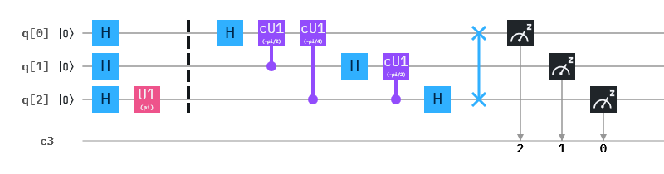
The code:
- OPENQASM 2.0;
- include "qelib1.inc";
- qreg q[3];
- creg c[3];
- h q[0];
- h q[1];
- h q[2];
- u1(pi) q[2];
- barrier q[0],q[1],q[2];
- h q[0];
- cu1(-pi/2) q[1],q[0];
- cu1(-pi/4) q[2],q[0];
- h q[1];
- cu1(-pi/2) q[2],q[1];
- h q[2];
- swap q[0],q[2];
- measure q[0] -> c[2];
- measure q[1] -> c[1];
- measure q[2] -> c[0];

The output:
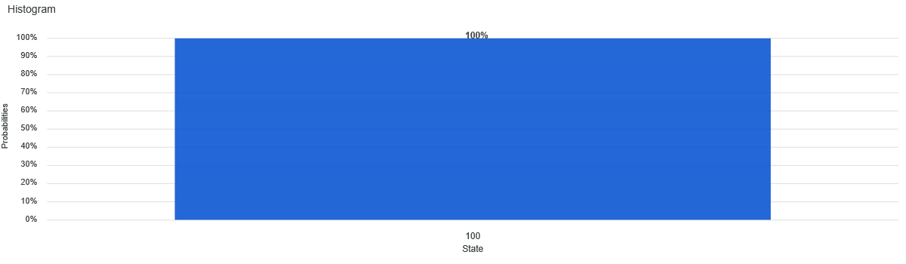
4.3 The mapping this oracle performs is $a_{1}a_{2}a_{3}→\frac{1}{2\sqrt{2}}e^{2πi×0.a_{2}a_{3}}=\frac{1}{2\sqrt{2}}e^{2πi\left(\frac{a_{2}}{2}+\frac{a_{3}}{4}\right)}$. The following table shows the particular results. Input 0/1 indicates that the respective value is either 0 or 1.
$$a_{1}$$ | $$a_{2}$$ | $$a_{3}$$ | $$\frac{1}{2\sqrt{2}}e^{2πi\left(\frac{a_{2}}{2}+\frac{a_{3}}{4}\right)}$$
0/1 | 0 | 0 | $$1/{2\sqrt{2}}$$
0/1 | 0 | 1 | $$i/{2\sqrt{2}}$$
0/1 | 1 | 0 | $${-1}/{2\sqrt{2}}$$
0/1 | 1 | 1 | $${-i}/{2\sqrt{2}}$$

The oracle oscillates between four values corresponding to rotations by$90°$. The frequency is 2, whereby the period equals 8/2=4. Our solution follows closely that already introduced in the material of this chapter. Quantum bits q[0], q[1], and q[2] correspond to $a_{1}, a_{2}, a_{3}$, respectively. 3 classical registers are needed to encode the output. The first column indicates that all 3 quantum bits are set into a uniform superposition by applying to them the Hadamard gate. In the next column, the respective rotations are encoded. In accordance with the mapping formula, quantum bit q[1] is rotated by $180°$, while q[2] is rotated by $90°$. These operations are delineated by the barrier. After the barrier, the inverse quantum Fourier transform is applied. This transformation is the same (starting in row 11 of the code) as in the chapter material, but applied to 3 quantum bits instead of 4. What changes is the application of the U1 gate to the qubits q[1] and q[2] corresponding to $a_{2}$ and $a_{3}$, respectively. Moreover, the swapping operation takes place between the most significant digit and the least significant digit only.
The circuit:
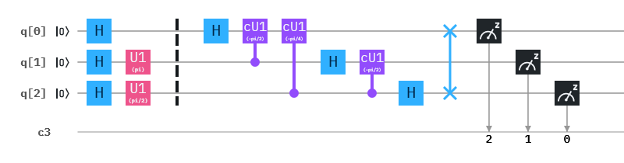
The code:
- OPENQASM 2.0;
- include "qelib1.inc";
- qreg q[3];
- creg c[3];
- h q[0];
- h q[1];
- h q[2];
- u1(pi) q[1];
- u1(pi/2) q[2];
- barrier q[0],q[1],q[2];
- h q[0];
- cu1(-pi/2) q[1],q[0];
- cu1(-pi/4) q[2],q[0];
- h q[1];
- cu1(-pi/2) q[2],q[1];
- h q[2];
- swap q[0],q[2];
- measure q[0] -> c[2];
- measure q[1] -> c[1];
- measure q[2] -> c[0];

The output:
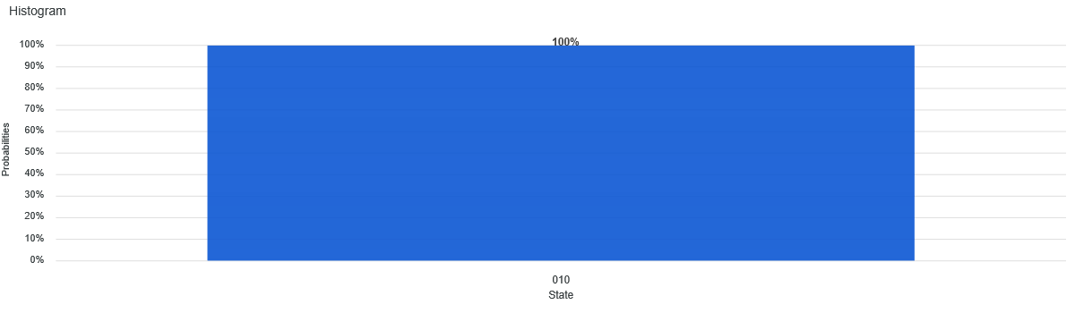

Solutions:

5.1 Since the remainder $r≠0$, $c=xd+r$, where xd is a multiple of d. From this it follows that $r=c-xd$. Let $b_{1}=gcd⁡(c,d)$ and let $b_{2}=gcd⁡(d,r)$. Then, on the one hand, $b_{1}|c$ and $b_{1}|d$, and also $b_{1}|xd$. With this, we have that $b_{1}|c-xd$ and thus $b_{1}|r$. Thus, $b_{1}|b_{2}$. On the other hand, $b_{2}|d$ and $b_{2}|r$. Hence, $b_{2}|xd$, from which it follows that $b_{2}|xd+r$ with $xd+r=c$. Thus, $b_{2}|b_{1}$. Therefore it must hold that $b_{1}=b_{2}$.

5.2 Let
$$Y_{i}=\frac{Y}{y_{i}}$$
Since $\gcd\left(y_{i},y_{j}\right)=1$ for each $i≠j$, it follows that $\gcd\left(Y_{i},y_{i}\right)=1$ as well. By Bézout’s identity there exist two integers $K_{i}$ and $k_{i}$ such that $K_{i}Y_{i}+k_{i}y_{i}=\gcd\left(Y_{i},y_{i}\right)=1$. Then a solution can be constructed as follows:
$$z=\sum_{i=1}^{n}{c_{i}K_{i}Y_{i}}$$
Each congruence relation $i$ is then represented as
$$z=c_{i}K_{i}Y_{i}=c_{i}\left(1-k_{i}y_{i}\right)=c_{i}(mod y_{i})$$
Moreover, any two solutions are equal modulo Y. To prove that let $z_{1}$ and $z_{2}$ be two solutions to the given system of equations. Since $y_{1}, y_{2}, ⋯, y_{n}$ are pairwise coprime, it follows that $y_{1}|(z_{1}-z_{2})$, $y_{2}|(z_{1}-z_{2})$, … $y_{n}|(z_{1}-z_{2})$. Thus, $y_{1}y_{2}⋯y_{n}|(z_{1}-z_{2})$, or, equivalently
$$z_{1}=z_{2}(mod y_{1}y_{2}⋯y_{n})$$

5.3 By the definition of binomial coefficients
$$\left(\begin{matrix}p \\ k\end{matrix}\right)=\frac{p!}{k!\left(p-k\right)!}=\frac{p\left(p-1\right)⋯\left(p-k+1\right)\left(p-k\right)!}{k!\left(p-k\right)!}=\frac{p\left(p-1\right)⋯(p-k+1)}{k!}$$
As binomial coefficients represent integers, $\frac{p\left(p-1\right)⋯(p-k+1)}{k!}$ is an integer. From the above equation it can be verified that $\left(\begin{matrix}p \\ k\end{matrix}\right)$ is a multiple of p. Hence, what must be shown is that $\frac{\left(p-1\right)⋯(p-k+1)}{k!}$ is an integer. To that end we use Euclid’s lemma. Euclid’s lemma states that if a prime n divides the product ab, where both a and b are integers, then n must divide at least one of them. Since $\frac{p\left(p-1\right)⋯(p-k+1)}{k!}$ is an integer, it follows that k! divides $p\left(p-1\right)⋯(p-k+1)$. Moreover, since k! does not divide p because p is prime, then by Euclid’s lemma, k! must divide $\left(p-1\right)⋯(p-k+1)$ and so $\frac{\left(p-1\right)⋯(p-k+1)}{k!}$ is an integer. Therefore, p divides $\left(\begin{matrix}p \\ k\end{matrix}\right)$.

5.4 This proof is due to James Ivory (“Demonstration of a theorem respecting prime numbers”, New Series of the Mathematical Depository, 1(2): 6-8, 1806). Let a be an integer and p be prime that does not divide a. The list of the first p-1 positive multiples of a is
$$a, 2a, 3a, ⋯, \left(p-1\right)a$$
By reducing each element modulo p, a new list is obtained that consists of a permutation of the integers $1, 2, 3, ⋯, p-1$. Therefore, multiplying the elements
$$a⋅2a⋅3a⋯\left(p-1\right)a=1⋅2⋅3⋯\left(p-1\right)(mod p)$$
This corresponds to
$$\left(p-1\right)!a^{p-1}=\left(p-1\right)!(mod p)$$
and further to
$$a^{p-1}=1(mod p)$$
Now let a be any integer and p be a prime. If $p|a$ then $a^{p}=a\left(mod p\right)=0$. If p does not divide a then multiplying the above equation by a
$$a⋅a^{p-1}=a(mod p)$$
gives the required result $a^{p}=a(mod p)$.

5.5 Consider the multiplicative group modulo $n$: $Z/nZ$. Every element in this group has a unique inverse. Let the elements of this group be denoted as $k_{1}, k_{2}, ⋯, k_{ϕ(n)}$. Then for $a∈Z/nZ$ the elements $ak_{1}, ak_{2},⋯, ak_{ϕ(n)}$ are also element of $Z/nZ.$ In analogy to the proof of Fermat’s little theorem, multiplying the elements $k_{i}$ corresponds then to
$$k_{1}⋅k_{2}⋯k_{ϕ\left(n\right)}=ak_{1}⋅ak_{2}⋯ak=a^{ϕ(n)}k_{1}⋅k_{2}⋯k_{ϕ\left(n\right)}$$
Cancelling equal terms leads to $a^{ϕ(n)}=1(mod n)$.

5.6 The following proof has been adapted from the proof given in “Continued Fractions, Pell's equation, and other applications" by Jeremy Booher and holds for any rational fraction, not only $\frac{i}{2^{n}}$.

Assume $\frac{i}{2^{n}}$ is not a convergent of the continued fraction of $\frac{i}{2^{n}}$. Then r can be picked to lie between the denominators of two convergents $\frac{p_{n}}{q_{n}}$ and $\frac{p_{n+1}}{q_{n+1}}$ of $\frac{i}{2^{n}}$, that is, $q_{n}<r<q_{n+1}$. Suppose
$$\left|z-r\frac{i}{2^{n}}\right|≤\left|p_{n}-q_{n}\frac{i}{2^{n}}\right| (1)$$
The determinant of the matrix in the following equation
$$\left(\begin{matrix}p_{n} & p_{n+1} \\ q_{n} & q_{n+1}\end{matrix}\right)\left(\begin{matrix}u \\ v\end{matrix}\right)=\left(\begin{matrix}z \\ r\end{matrix}\right)$$
is 1 or -1 based on the difference between two successive convergents, which is given by
$$\frac{p_{n+1}}{q_{n+1}}-\frac{p_{n}}{q_{n}}=\frac{{\left(-1\right)}^{n}}{q_{n}q_{n+1}}$$
Then for the system of equations
$$z=up_{n}+vp_{n+1} (2)$$
$$r=uq_{n}+vq_{n+1}$$
holds that $uv≤0$. u and v cannot be both positive or both negative beause this would imply that $\left|r\right|>|q_{n+1}|$ which contradicts our assumption that $q_{n}<r<q_{n+1}$.
With (2) we have
$$\left|z-r\frac{i}{2^{n}}\right|=\left|\left(up_{n}+vp_{n+1}\right)-\left(uq_{n}+vq_{n+1}\right)\frac{i}{2^{n}}\right|=\left|u\left(p_{n}-q_{n}\frac{i}{2^{n}}\right)+v\left(p_{n+1}-q_{n+1}\frac{i}{2^{n}}\right)\right|$$
Since even convergents are increasing and odd convergents are decreasing with $\frac{i}{2^{n}}$ lying in between them, and given that $uv≤0$, it must be that either (1) $u\left(p_{n}-q_{n}\frac{i}{2^{n}}\right)$ and $v\left(p_{n+1}-q_{n+1}\frac{i}{2^{n}}\right)$ have the same sign, or (2) one of them is zero. Therefore,
$$\left|z-r\frac{i}{2^{n}}\right|=\left|u\left(p_{n}-q_{n}\frac{i}{2^{n}}\right)\right|+\left|v\left(p_{n+1}-q_{n+1}\frac{i}{2^{n}}\right)\right|$$
For

$$\left|z-r\frac{i}{2^{n}}\right|<\left|p_{n}-q_{n}\frac{i}{2^{n}}\right|$$
to be true, either (1) $\left|u\right|=1$ and $v = 0$, or (2) $u = 0$. Assuming (1) is the case, then $\frac{z}{r}=\frac{p_{n}}{q_{n}}$ and is thus a convergent of $\frac{i}{2^{n}}$. Assuming (2) is the case, then $\left|r\right|=|vq_{n+1}|$, which contradicts our assumption that $r < q_{n+1}$.
As opposed to equation (1) suppose that
$$\left|z-r\frac{i}{2^{n}}\right|≥\left|p_{n}-q_{n}\frac{i}{2^{n}}\right|$$

Then
$$\left|p_{n}-q_{n}\frac{i}{2^{n}}\right|<\frac{1}{2r}$$
From this it follows that
$$\left|\frac{z}{r}-\frac{p_{n}}{q_{n}}\right|≤\left|\frac{z}{r}-\frac{i}{2^{n}}\right|+\left|\frac{p_{n}}{q_{n}}-\frac{i}{2^{n}}\right|<\frac{1}{2r^{2}}+\frac{1}{q_{n}q_{n+1}}≤\frac{1}{2rq_{n}}+\frac{1}{2q_{n}r}=\frac{1}{rq_{n}} (3)$$
However
$$\left|\frac{z}{r}-\frac{p_{n}}{q_{n}}\right|=\left|\frac{zq_{n}-rp_{n}}{rq_{n}}\right| (4)$$
Since due to (3)
$$\left|zq_{n}-rp_{n}\right|≤1$$
and because we assumed that z and r are positive integers and therefore the nominator in (4) has to be an integer, we have
$$\left|zq_{n}-rp_{n}\right|=1$$
which implies that $\frac{z}{r}$ is a convergent of $\frac{i}{2^{n}}$.

5.7
$${\left|1-e^{iθ}\right|}^{2}=\left(1-e^{iθ}\right)\left(1-e^{-iθ}\right)=1-e^{-iθ}-e^{iθ}+1=2-\left(\cos{θ-i\sin{θ}}\right)-\left(\cos{θ+i\sin{θ}}\right)=2-2\cos{θ}$$
Let $δ=\frac{θ}{2}$. Then by trigonometric identity formula for double angles $\cos\left(2θ\right)=1-2\sin^{2}{\frac{θ}{2}}$ we obtain
$$2-2\cos\left(2δ\right)=2-2\left(1-2\sin^{2}{δ}\right)=4\sin^{2}{δ}=4\sin^{2}{\frac{θ}{2}}$$

Solutions to exercises in chapter 6:

6.1 Let $|x_{0}⟩$ be the only solution of a given search problem. Then, recalling that the inner product $\left\langle x | x\right\rangle =1$, we have
$$O\left|x_{0}\right\rangle =\left(I-2 | x_{0}\right\rangle ⟨x_{0}|)\left|x_{0}\right\rangle =I\left|x_{0}\right\rangle -2\left|x_{0}\right\rangle \left\langle x_{0} | x_{0}\right\rangle =\left|x_{0}\right\rangle -2\left|x_{0}\right\rangle =-|x_{0}⟩$$

6.2 For $\left|x_{0}\right\rangle =\left|2\right\rangle =|10⟩$ the matrix has dimensions 4x4 and can be derived as follows:
$$\left[\begin{matrix}\begin{matrix}1 & 0 \\ 0 & 1\end{matrix} & \begin{matrix}0 & 0 \\ 0 & 0\end{matrix} \\ \begin{matrix}0 & 0 \\ 0 & 0\end{matrix} & \begin{matrix}1 & 0 \\ 0 & 1\end{matrix}\end{matrix}\right]-2\left[\begin{matrix}\begin{matrix}0 \\ 0\end{matrix} \\ \begin{matrix}1 \\ 0\end{matrix}\end{matrix}\right]\left[\begin{matrix}\begin{matrix}0 & 0\end{matrix} & 1 & 0\end{matrix}\right]=\left[\begin{matrix}\begin{matrix}1 & 0 \\ 0 & 1\end{matrix} & \begin{matrix} 0 & 0 \\ 0 & 0\end{matrix} \\ \begin{matrix}0 & 0 \\ 0 & 0\end{matrix} & \begin{matrix}-1 & 0 \\ 0 & 1\end{matrix}\end{matrix}\right]$$

6.3 First, derive $U=2|ϕ_{1}⟩⟨ϕ_{1}|-I$
$$U=2\left[\begin{matrix}\sqrt{\frac{N-S}{N}} \\ \sqrt{\frac{S}{N}}\end{matrix}\right]\left[\begin{matrix}\sqrt{\frac{N-S}{N}} & \sqrt{\frac{S}{N}}\end{matrix}\right]-\left[\begin{matrix}1 & 0 \\ 0 & 1\end{matrix}\right]=\left[\begin{matrix}\frac{N-2S}{N} & \frac{2\sqrt{S(N-S)}}{N} \\ \frac{2\sqrt{S(N-S)}}{N} & \frac{2S-N}{N}\end{matrix}\right]$$
Then applying U to $|ϕ_{2}⟩$ we obtain $|ϕ_{3}⟩$

$$U\left[\begin{matrix}\sqrt{\frac{N-S}{N}} \\ \sqrt{\frac{S}{N}}\end{matrix}\right]=\left[\begin{matrix}\sqrt{\frac{N-S}{N}}\frac{N-4S}{N} \\ \sqrt{\frac{S}{N}} \frac{3N-4S}{N}\end{matrix}\right]$$
Thus U has reflected vector $|ϕ_{2}⟩$ about $|ϕ_{1}⟩$ as shown in Fig. 6.7.

6.4 The matrix of G is
$$G=\left[\begin{matrix}\cos{θ} & -\sin{θ} \\ \sin{θ} & \cos{θ}\end{matrix}\right]$$
From the state $\left|ϕ_{1}\right\rangle$ we have that $\sin{\frac{θ}{2}=\sqrt{\frac{S}{N}}}$ and $\cos{\frac{θ}{2}=\sqrt{\frac{N-S}{N}}}$. From the state $|ϕ_{3}⟩$ we have that $\sin{\frac{3θ}{2}}=\frac{3N-4S}{N}\sqrt{\frac{S}{N}}$ while $\cos{\frac{3θ}{2}}=\frac{N-4S}{N}\sqrt{\frac{N-S}{N}}$. The elements of Grovers operator can then be obtained from the following triginometric identities
$$\sin{θ=\sin\left(\frac{3θ}{2}-\frac{θ}{2}\right)}=\sin{\frac{3θ}{2}}\cos{\frac{θ}{2}}-\cos{\frac{3θ}{2}}\sin{\frac{θ}{2}}=\frac{2\sqrt{S(N-S)}}{N}$$
$$\cos{θ=\cos\left(\frac{3θ}{2}-\frac{θ}{2}\right)}=\cos{\frac{3θ}{2}}\cos{\frac{θ}{2}+\sin{\frac{3θ}{2}}}\sin{\frac{θ}{2}}=\frac{N-2S}{N}$$
With the above the mtrix has the form
$$G=\left[\begin{matrix}\frac{N-2S}{N} & -\frac{2\sqrt{S(N-S)}}{N} \\ \frac{2\sqrt{S(N-S)}}{N} & \frac{N-2S}{N}\end{matrix}\right]$$

6.5 We need to solve the equation
$$G\left|ψ\right\rangle =λ|ψ⟩$$
where $|ψ⟩$ is an eigenvector and $λ$ is its corresponding eigenvalue. To that end we find the characteristic equation
$$\left|G-λI\right|=0$$
to be
$$\left|\left[\begin{matrix}\frac{N-2S}{N} & -\frac{2\sqrt{S(N-S)}}{N} \\ \frac{2\sqrt{S(N-S)}}{N} & \frac{N-2S}{N}\end{matrix}\right]-\left[\begin{matrix}λ & 0 \\ 0 & λ\end{matrix}\right]\right|=\left|\left[\begin{matrix}\frac{N-2S}{N}-λ & -\frac{2\sqrt{S(N-S)}}{N} \\ \frac{2\sqrt{S(N-S)}}{N} & \frac{N-2S}{N}-λ\end{matrix}\right]\right|={\left(\frac{N-2S}{N}-λ\right)}^{2}+{\left(\frac{2\sqrt{S(N-S)}}{N}\right)}^{2}=λ^{2}-\frac{2N-4S}{N}λ+1=0$$
The two eigenvalues are therefore (the complex value is due to the fact that $N≤S$)
$$λ_{1}=\frac{N-2S+2i\sqrt{S(N-S)}}{N}$$
and
$$λ_{2}=\frac{N-2S-2i\sqrt{S(N-S)}}{N}$$
The corresponding eigenvectors are calculated as follows. For $λ_{1}$
$$\left[\begin{matrix}\frac{N-2S}{N}-λ_{1} & -\frac{2\sqrt{S(N-S)}}{N} \\ \frac{2\sqrt{S(N-S)}}{N} & \frac{N-2S}{N}-λ_{1}\end{matrix}\right]\left|ψ_{1}\right\rangle =\left[\begin{matrix}-\frac{2i\sqrt{S\left(N-S\right)}}{N} & -\frac{2\sqrt{S\left(N-S\right)}}{N} \\ \frac{2\sqrt{S\left(N-S\right)}}{N} & -\frac{2i\sqrt{S\left(N-S\right)}}{N}\end{matrix}\right]\left[\begin{matrix}ψ_{1,1} \\ ψ_{1,2}\end{matrix}\right]=0$$
and hence $ψ_{1,1}=iψ_{1,2}$. Therefore the eigenvector is $\frac{1}{\sqrt{2}}\left[\begin{matrix}i \\ 1\end{matrix}\right]$. For $λ_{2}$
$$\left[\begin{matrix}\frac{N-2S}{N}-λ_{2} & -\frac{2\sqrt{S(N-S)}}{N} \\ \frac{2\sqrt{S(N-S)}}{N} & \frac{N-2S}{N}-λ_{2}\end{matrix}\right]\left|ψ_{1}\right\rangle =\left[\begin{matrix}\frac{2i\sqrt{S\left(N-S\right)}}{N} & -\frac{2\sqrt{S\left(N-S\right)}}{N} \\ \frac{2\sqrt{S\left(N-S\right)}}{N} & \frac{2i\sqrt{S\left(N-S\right)}}{N}\end{matrix}\right]\left[\begin{matrix}ψ_{1,1} \\ ψ_{1,2}\end{matrix}\right]=0$$
and hence $ψ_{1,1}=\frac{1}{i}ψ_{1,2}$. This corresponds to the eigenvector $\frac{1}{\sqrt{2}}\left[\begin{matrix}-i \\ 1\end{matrix}\right]$.

